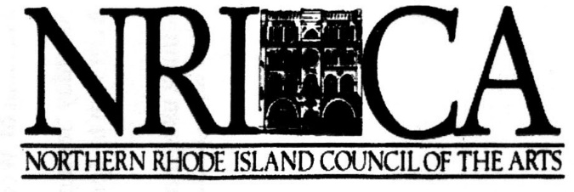

Membership Application

Membership Level

Individual or Family: $10.00

*Sponsor: $50.00

*Patron: $100.00

*Benefactor: $500.00

*Corporate Sponsor: $

* all Membership Privileges plus special recognition in event programs

* First name |  | * Last name:
Business:
* Street Address:
Street Address:
* City: |  | * State: | *Zip:
*Phone: |  | E-mail:
* required fields

You may print this form and send with payment to: | NRICA  P.O. Box 1723  Woonsocket, RI 02895

NRICA does not share or sell phone or mailing lists

